SAS Util Scripts for PSPad

John Hendrickx
John2.Hendrickx@gmail.com

May 20, 2009

SAS Util scripts

Run SAS
Press Ctrl+Shift+R to run the current SAS file in batch mode. After the file has run, the log file and listing (if generated) will be opened or updated.

Checking the SAS log file
Press Ctrl+Alt+L to check a SAS log file for errors, warnings, or relevant notes. The screen will be split horizontally, with a list of errors/warnings/notes in the lower half:

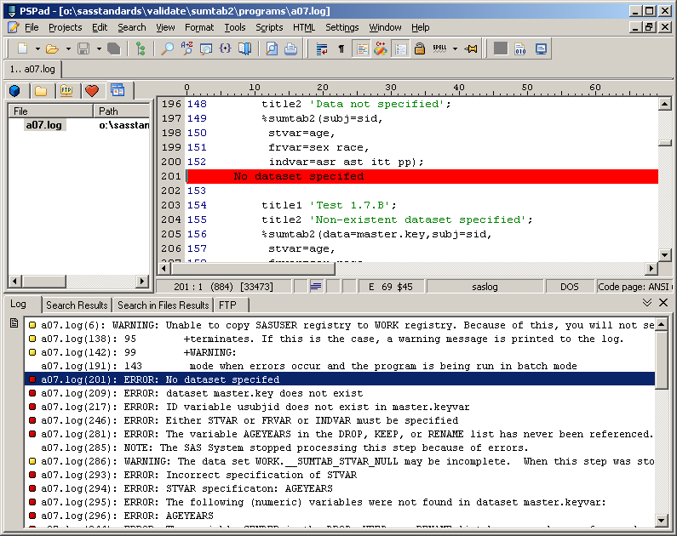

Check all SAS logs
To check all SAS logs, press Shift+Ctrl+Alt+L or use the menus “Script”, SAS, “SASlogCheckAll”. The script will check all SAS log files in the current directory and will create and open the following three files:

- log_errors.txt
- log_warnings.txt
- log_notes.txt

The file will be empty if no log messages occurred of the type specified.

Miscellaneous scripts
- Press Ctrl+Shift+C to insert comments /* */ in the selected lines
- Press Ctrl+Alt+C to remove comments /* */ from the selected lines
- Press Ctrl+Shift+D to insert the current date (as e.g. 01JAN2009)
- Press Ctrl+Shift+N to insert the filename of the current file
- Use the menus “Script”, “Insert Info”, “Report All Macros” for a list of all SAS macros in the current document, including macros called from within a SAS macro.

Installing the PSPad Scripts
copy *.js "C:\Program Files\PSPad editor\Script\JScript\"
copy *.vbs "C:\Program Files\PSPad editor\Script\VBScript\"

Configuring Windows Explorer to open SAS files with PSPad
Normally, if you double-click a SAS file in the Windows Explorer, it will be opened in SAS. To change this behavior, use the menus “Tools”, “Folder Options…” in Windows Explorer, then select the “File Types” tab. Scroll down to the SAS extension (file type “SAS Program”), then click on the “Advanced” button. Select “Open”, then click the “Edit…” button. Use the “Browse…” button to select "C:\Program Files\PSPad editor\PSPad.exe" followed by "%1" (the quotation marks are to be included).

There are easier way to change the association of the .SAS extension with a Windows program but this method will leave the context menus “Batch Submit with SAS 9.1 - Clinquest” and other settings intact.

The shortcut key Ctrl+/ is not available for script commands in the current version of PSPad

